Ali Salhi | 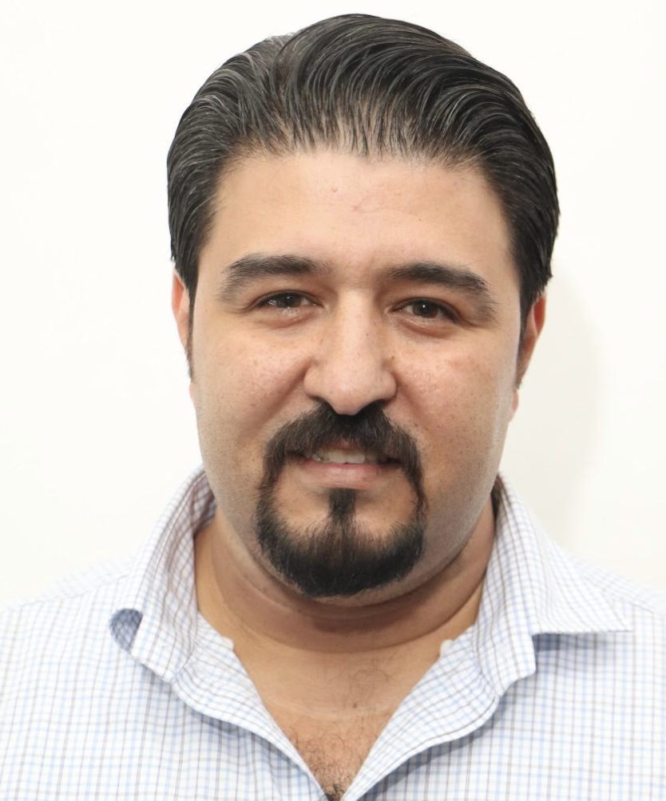
AI R&D Engineer
Email: eng.salhi.ali@gmail.com
LinkedIn: http://www.linkedin.com/in/asalhi85

Kaggle: https://www.kaggle.com/asalhi
2x Kaggle Competition Master (Best Worldwide Rank: 10th) | Co-Founder @ STEAM for Innovation & Education | AI R&D Engineer | 11 Global Awards

Bio:
I am a senior researcher, data scientist, AI practitioner, and lecturer with over 20 years of experience in Natural Language Processing, Information Retrieval, Machine Learning, Artificial Intelligence, and software development.
My work combines AI research, data science, software engineering, and education. I have more than 13 years of hands-on AI experience and have participated in over 120 global AI competitions and projects. I am a 2x Kaggle Master, achieved a top-10 ranking in Kaggle competitions, won 11 global awards, developed innovative and award-winning solutions, and contributed to academic publications.
My technical expertise includes Python, Java, C/C++, Objective-C, Web Services, APIs, Android, and iOS development. I also have 13 years of experience in STEAM education, including educational robotics, electronics, and interdisciplinary learning experiences that integrate arts, science, and engineering.
As a lecturer, I teach computer science, artificial intelligence, programming, and management, with a strong focus on connecting academic knowledge, real-world applications, and innovation.

Awards
- Winner of “Mohammed Bin Rashid Award for Arabic Language 2025”.
Project ArabiTools: a suite of software tools serving the Arabic language.
- 1st Place winner - "Make Data Count - Finding Data References" global competition

- 3rd Place winner - Kaggle annual global optimization challenge - developed an algorithm for text perplexity efficient calculation - 2024
- 1st Place winner (out of 16,788 participants) - SmartathonChallenge (The smart cities global challenge) by SDAIA | سدايا!

- 1st Place winner “The Arabic Barmajan 2022” (Arabicthon) in the Arabic Poems Challenge (Winning idea Alrawyiah) from King Salman Global Academy for the Arabic Language.

- Winner of The Arabic Sentiment Analysis Challenge Award 2021 By King Abdullah University of Science and Technology - 2nd Place.
https://wti.kaust.edu.sa/SoD/Arabic-Sentiment-Analysis-Challenge
- Winner of ALESCO “Arab League Educational, Cultural and Scientific Organization “ Mobile Apps Competition Award 2016 - 1st Place for Yorwa Search Engine App (First Place Palestine & First Place Middle East)
- Winner of “H.H. Sheikh Salem Al-Ali Al-Sabah Informatics Award 2013” for Yorwa Search Engine. - 1st Place.
- Winner of Mobily (Saudi Telecommunication Company) Mobile App Competition 2012, under the category "Best Mobile App Idea" for Yorwa android application. - 1st Place.
- Google Research Award (under the supervision of Prof. Adnan Yahya ) for the year 2009. Research Topic: "A Suite of Automated Tools for Efficient Management and Search in Web-based Arabic Documents”.
- Awarded 1st prize in the Information Technology Student's Activity Fair (ITSAF 2008) for the best graduation project. (my project was Wojood, Arabic Search Engine, and Aiding tools), The Fair was held on July 23rd – 24th, 2008 in Petra University, Amman, Jordan.

Achievements
- Certified 2 x Master (10th worldwide) by Kaggle, one of the world's top AI/data science communities.
- Shortlisted as a finalist in MIT Technology Review Innovators Under 35 - MENA (IU 35 MENA) for the year 2018.
- Selected in the honor list of the best 100 personalities who contributed to the publication of the Arabic language for the year 2018 through the International eTurn Council.
- Selected in the honor list of the 1st National Forum for Creativity and Leadership in Palestine - 2016

Publications
- Adnan Yahya and Afnan Ahmad and Alaa Assaf and Rawan Khater and Ali Salhi. “Models for Arabic Document Quality Assessment”. 3rd Workshop on Quality of Open Data (QOD 2020). June 8-10, 2020. Colorado Springs, USA.
- Abdelrahman, I., & Salhi, A. Y. (2020). Understanding the factors affecting the adoption of e-learning by teachers from East Jerusalem schools. Ortadoğu ve Göç, 10(20), 305-348.
- ABDELRAHMAN, Inas, and Ali Yousef Salhi. "Understanding the Factors Affecting the Adoption of E-Learning by Teachers from East Jerusalem Schools." Ortadoğu ve Göç 10.20: 305-348.
- Ali Salhi and A. Yahya “Document Similarity for Arabic and Cross-Lingual Web Content”; Arabic Language Processing: From Theory to Practice Book, Chapter 10; Springer International Publishing, ISBN 978-3-319-73500-9 (March 2018)
http://www.springer.com/us/book/9783319734996
- Ali Salhi and A. Yahya "Document Similarity for Arabic and Cross-Lingual Web Content"; Proceedings of the 6th International Conference on Arabic Language Processing - ICALP 2017; October 11th -12th, 2017, Fez, Morocco.
- Jarrar, M., Yahya, A., Salhi, A., Abu Helou, M., Hicks, A., Fellbaum, C., ... & Palmonari, M. (2014). Arabization and multilingual knowledge sharing. EU-FP7 SIERA Project FP7-INCO-2011-6-295006.
- Abdelmalek Halawani and Ali Salhi: “A Proposed Structure to Integrate Robotics Activities for Science & Mathematics in Secondary Schools.” Proceedings of The 4th Arab Conference on Robotics and Artificial Intelligence, 2016.
- Ali Salhi and Adnan Yahya: “Quality Assessment of General and Categorized Arabic Text Corpora“; Proceedings of the 5th International Conference on Arabic Language Processing – CITALA 2014: November 26-28, 2014, Oujda, Morocco.
- Adnan Yahya and Ali Salhi: "Quality Assessment of Arabic Web Content: The case of the Arabic Wikipedia"; Proceedings of Innovations'14: The 10th International Conference in Innovation in Information Technology; Special Session on Arabic NLP; Nov. 9 --11, 2014, UAE.
- Adnan Yahya and Ali Salhi: "Arabic Text Categorization Based on Arabic Wikipedia"; ACM Transactions on Asian Language Information Processing; (TALIP) 13 (1), 4; 2014.
- Adnan Yahya and Ali Salhi: "Arabic Text Correction Using Dynamic Categorized Dictionaries: A Statistical Approach"; Linguistica Communicatio Journal; Vol 5; 2013. Selected for Journal publication from the 4th International Conference on Arabic Language Processing-CITALA 2012.
- Adnan Yahya and A. Salhi: "Arabic Text Correction Using Dynamic Categorized Dictionaries: A Statistical Approach"; Proceedings of 4th International Conference on Arabic Language Processing-CITALA 2012; May 1-2, 2012, Rabat, Morocco.
- Ali Salhi and A. Yahya: "Tools For Arabic People Names Processing And Retrieval: A Statistical Approach"; Proceedings of ALTIC 2011: Arabic Language Technology International Conference; October 09-10, 2011, Bibliotheque Alexandria, Alexandria, Egypt.
- Ali Salhi (2011). "Cloud Computing What, When, Why And How CIOs Should Deal With It" [White Paper], http://whitepapers.zdnet.com/abstract.aspx?docid=3270775
- Adnan Yahya and A. Salhi: "Enhancement Tools for Arabic Web Search: A Statistical Approach"; Proceedings of Innovations 2011: The Seventh International Conference in Innovation in Information Technology: Special Session on Arabic NLP; April 25-27, 2011, Abu Dhabi, UAE.
- Adnan Yahya, A. Hithnawi, A. Salhi, and M. Fawadleh: "Statistical/Corpus-Based Methods for Improved Bilingual (Arabic/English) Web Search"; Proceedings of the Humboldt Kolleg on Human Language Technologies in Africa: Status and Prospects; June 3–5, 2008, Rabat – Morocco.

Education
Birzeit University 2009 - 2012
Master of Business Administration, GPA 87%

Birzeit University 2003 -2008
B.A, Computer Systems Engineering, GPA 82%.

Professional Work
- ArabiTools: Programming Tools for Arabic Language Nov 2017 - Present
Founder
- STEAM Ltd. for Innovation and Education May 2016 - Present
Co-Founder and Director of R&D
- Android/iOS & Java/Swift ToT (Consultancy Services) May 2016 - Present
JEST, The Ministry of Education, Schools
- AI, Robotics & Electronics ToT (Consultancy Services) Dec 2014 – Present
Educational Counseling Center, FHF, MoE – Jerusalem
- Robotics Trainer & FLL Coach (Part-time) Feb 2014 - Jun 2025
The Academy of Excellence “YOUniversity” - Jerusalem
- AI Researcher & Senior Developer (​Consultancy Services) Jan 2014 – Nov 2016
Birzeit University, PS –MoHE Funded Project in the field of Arabic text and information
quality.
- Lecturer & Robotics ToT (Part-Time) Sep 2013 – May 2016
Wajdi University College of Technology – Jerusalem
- Lecturer (Part-Time) Sep 2013 – Jan 2014
AlQuds Open University – Jerusalem Branch
- NLP/AI Researcher and Developer Sep 2011 – Aug 2014
Academic Affairs Office, Birzeit University, Google Research Award & SIERA (FP7)
- Trainer (Programming for Kids – Scratch) (Consultancy Service) Jul 2013
Najjad Zeenni IT Center of Excellence.
- Teaching & Research Assistant Sep 2008 – Aug 2011
IT College, Birzeit University

Selected Projects
Baseer (1 Award): Baseer is a developed automated system that locates visual pollution by relying on artificial intelligence techniques to analyze live street streams and extract data. It's based on a state-of-the-art trained model, which was trained using Detectron and Yolo with multiple learning phases.

Alrawiyah (2 Awards): Arabic AI System for connecting photos with proverbs and poems. The system uses deep learning models to learn about Arabic poems and photos and find connections between them.

ArabiTools: A free Java/Python-based AI Library for Arabic Language Processing. (1 Award):
Arabi Tools includes free programming libraries that aim to motivate developers to use the Arabic Language in their applications and products, the tools are distributed over different categories such as Arabic verbs processing tools, People names processing tools, Arabic social media tools, Arabic text classification, and Arabic Named Entities Recognition, Wikipedia processing.
For full details, please check https://www.arabitools.com/
Yorwa: Arabic Search Engine for Socially Shared Arabic Proverbs (3 Awards)
Yorwa is a search engine dedicated to finding short quotes from social networks. Yorwa depends on algorithms that monitor public entries on social networks and extract Arabic quotes and proverbs. - Yorwa was discontinued due to lake of funding in 2020.

Wojood: Arabic Search Engine and Aiding Tools (2 Awards) – Partially funded by Google Research Award.
Wojood is an Arabic Search engine, with designed APIs for Arabic search and query analysis. APIs include basic searching and crawling, bookmarking, and Arabic natural language processing for queries.

Courses I Teach
Programming-Based:
Machine Learning, Python, Java Programming (Introduction, OOP & Data Structure), Advanced Programming (Mobile “Android/iOS” and Web Services), Data Structure, Programming for kids (Scratch, HoC, CodeCombat, CodeMonkey)
Electronics-Based:
Robotics (Lego EV3, WeDo, MakeWonder, Cubelets, EdisonBots ...) & Electronics (LittleBits, SNAP Circuits & Arduino ), MicroBits, Digital Circuits, Real-Time Systems.
Business-Based:
E-Business, Project Management, Quality Assurance, Databases, Introduction to microeconomics, Purchasing & Inventory Management, Introduction to Sales Management.
Computing in Education:
TOT in online Lecturing and Meeting skills, Educational Computing Tools, online Evaluation Tools, Tools for computing lessons, AI tools, and Escape Rooms in Education.

